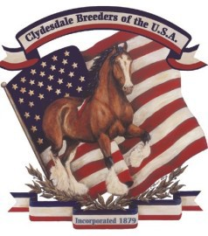
APPLICATION FOR TRANSFER

GRADE-UP
Secretary of the Clydesdale Stud Book of the United States Please complete and send to:
Clydesdale Breeders of the U.S.A. PO Box 345 Fredericktown, Ohio 43019
Phone: 815-247-8780—Email: secretary@clydesusa.com—www.clydesusa.com

Name of Animal: Registration # Sex: Female: Gelding (Date Gelded) I hereby certify that on the Day of Month 20 I (we) Sold the above Clydesdales to: Buyers name: Address: City: State: Zip Code:
Email: Phone:
If the animal above is a female, and was served previous to delivery, the date of service and name and number of the stal- lion must be given and be signed by the owner of the stallion or lessee of sire at the time of service:
Served on day of Month 20 by Stallion: Registration # of Stallion: Signature of Stallion Owner/Lessee:
The foregoing statements are true and correct and are made for the purpose of obtaining a transfer on the records of the Clydesdale Breeders of the U.S.A. I hereby authorize the transfer of ownership as above, on the books of the Clydesdale Breeders of the U.S.A.
Signature of Seller(s) Sellers Address: Date: Telephone Number: Email:
Rules & Fees for Transfers
When change of ownership occurs, the seller is responsible to transfer said horse into the new buyer’s name. After filling out the transfer form, the original pedigree on the horse along with the transfer form and fees should be submitted to the Clydesdale Breeders Office. An open transfer is in direct violation of the Association Rules. This means handing the new buyer a transfer that is not filled out and recorded with the Association is not acceptable.

The fee for transfer is based on whether the seller is a member of the Association and also on the date of sale and can be found on CBUSA fee schedule.

Checklist:
Completed Application Original Pedigree of animal Certificate of Service signed if required Fees Payable To Clydesdale Breeders Of the U.S.A.—Visa or Mastercard

